Step Response and Advance Filter Topics
(Final Report – Experiment #6)

Vega, Roberto Javier SID: 003 110 717
Partner: Eddie Esquivel
EE 110L
LAB 6
Objectives:

- To investigate the step response of capacitive and inductive circuits
- To design and measured an advanced RC filter.

Theory:

- Circuits
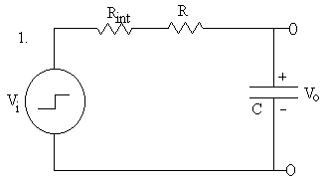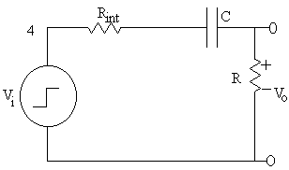
τ = RC

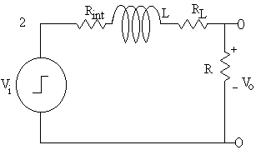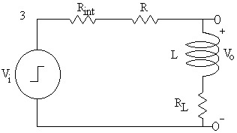
τ = L / R_{total}

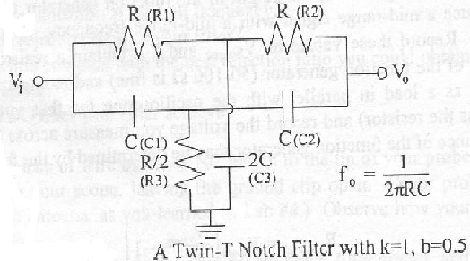

Procedure:

We started by measuring the internal resistance of the function generator when it produces square waves. To do this we started by applying a square wave of 10Vpp and 1 kHz to the circuit described in the lab manual, for this part V_{source} was measured. Then, a load resistor in the range of 50Ω to 100Ω was connected parallel with the function generator and V_{load} was measured.
For the next part of the experiment, we constructed the circuits described in the lab manual and we choose the values of R, L, and C, so that we selected a 10% of the reciprocal of τ calculated in the theory. We did this for each circuit in the theory part. Then, using a square wave, V_{o} was measured by the oscilloscope, which was adjusted to get one cycle on screen. Finally, τ was calculated and measured. We also draw the graphs described in the manual and we calculated the theoretical parts.
For the last part of this lab, we constructed the Twin-T Notch Filter, described in the theory part of this report. For the circuit we calculated the frequency that was blocked, first by theory and later by the measurements obtained in the laboratory.

Data Obtained Experimentally of each circuit:

Data Analysis and Plots:

Conclusion:

In conclusion, the experiment was very successful. The step response of RL and RC circuits was investigated. Moreover, a T-Twin notch filter was designed and constructed, which had a notch frequency of 60Hz. Also, this experiment helped us the gain more experience understanding how the frequency filters work and how the step response of a circuit is analyzed. Therefore, all the objectives of this experiment were achieved successfully.

